• Mall_Customers.csv.xlsx

1.Here I have first viewed the first five records from the data using df.head()
index | CustomerID | Gender | Age | Annual_Income_(k$) | Spending_Score_ (1-100)
0 | 1 | Male | 19 | 15 | 39
1 | 2 | Male | 21 | 15 | 81
2 | 3 | Female | 20 | 16 | 6
3 | 4 | Female | 23 | 16 | 77
4 | 5 | Female | 31 | 17 | 40

2. Given the code to find the Annual income based on Gender
Gender | Annual_Income_(k$)
Female | 6636
Male | 5476

3. Checked for Annual income based on Grouping Age of the customers
Age | Annual_Income_(k$)
18 | 205
19 | 456
20 | 208
21 | 194
22 | 94
23 | 249
24 | 157
25 | 173
26 | 116
27 | 379
28 | 341
29 | 318
30 | 533
31 | 387
32 | 959
33 | 241
34 | 395
35 | 420
36 | 486
37 | 195
38 | 447
39 | 218
40 | 370
41 | 202
42 | 120
43 | 197
44 | 151
45 | 208
46 | 177
47 | 421
48 | 291
49 | 357
50 | 293
51 | 111
52 | 111
53 | 79
54 | 239
55 | 57
56 | 79
57 | 129
58 | 108
59 | 261
60 | 130
63 | 113
64 | 19
65 | 101
66 | 126
67 | 182
68 | 170
69 | 44
70 | 95

4. Given df.describe command to get the below information
 | CustomerID | Age | Annual_Income_(k$) | Spending_Score_(1-100)
count | 200.000000 | 200.000000 | 200.000000 | 200.000000
mean | 100.500000 | 38.850000 | 60.560000 | 50.200000
std | 57.879185 | 13.969007 | 26.264721 | 25.823522
min | 1.000000 | 18.000000 | 15.000000 | 1.000000
25% | 50.750000 | 28.750000 | 41.500000 | 34.750000
50% | 100.500000 | 36.000000 | 61.500000 | 50.000000
75% | 150.250000 | 49.000000 | 78.000000 | 73.000000
max | 200.000000 | 70.000000 | 137.000000 | 99.000000

5. Given the command df.groupby("Age")["Annual_Income_(k$)"].mean() to group set of Age group customers and their Annual income
Age | Annual_Income_(k$)
18-25 | 45.029412
26-35 | 68.150000
36-50 | 66.661290
50+ | 53.850000

6. Applied the scatter plot code to get the below plot between Age and Annual income of the customers

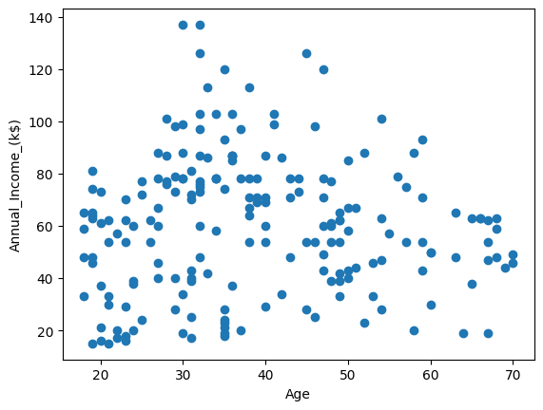

For strong analytical visualization Boxplot is used to understand the Annual income for certain age customers
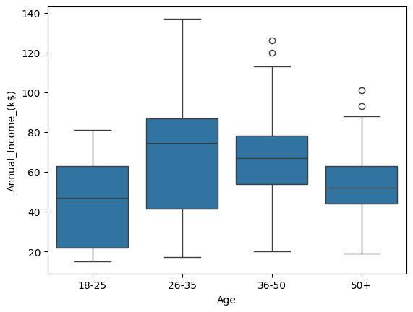
Insights:
The 26–35 age group shows the highest median income and the greatest variability, indicating peak earning potential and diverse career growth paths. Income stabilizes in the 36–50 group, while younger and older groups show lower and more consistent income levels.

7. Using scatter plots, I observed that income does not have a strong linear relationship with age. However, mid-career professionals (30–45) tend to have higher earning potential, while income variability is highest in this group. This suggests that factors like experience and role play a bigger role than age alone.

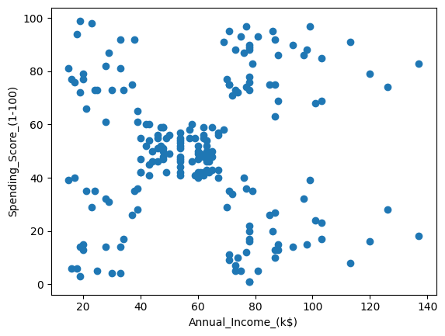

8. Customer segmentation using KMeans clustering identified five distinct customer groups, enabling targeted marketing strategies such as loyalty programs for high-value customers and engagement strategies for potential customers.

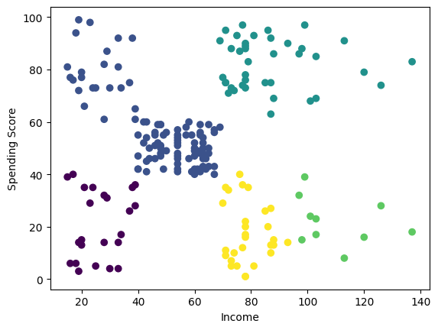

Cluster centers revealed distinct customer segments such as premium customers (high income, high spending) and potential customers (high income, low spending), enabling targeted business strategies.

